## San Francisco State University

## CSC 648 - 848

## Milestone 0 Submission Form

**Section 01 Team 02**

|  |  |
| --- | --- |
| Item | Credentials |
| Website URL | http://13.57.3.194/ |
| SSH URL | ubuntu@ec2-13-57-3-194.us-west-1.compute.amazonaws.com |
| SSH Username | ubuntu |
| SSH Password/Key | CSC648.pem and CSC648.ppk keys attached in the email |
| Database URL | Please refer the below information. |
| Database Username | NA |
| Database Password | NA |

We used Robo 3T v 1.4.4 to connect to the database.

Below are the screenshot to connect to our database.

Connection Tab:

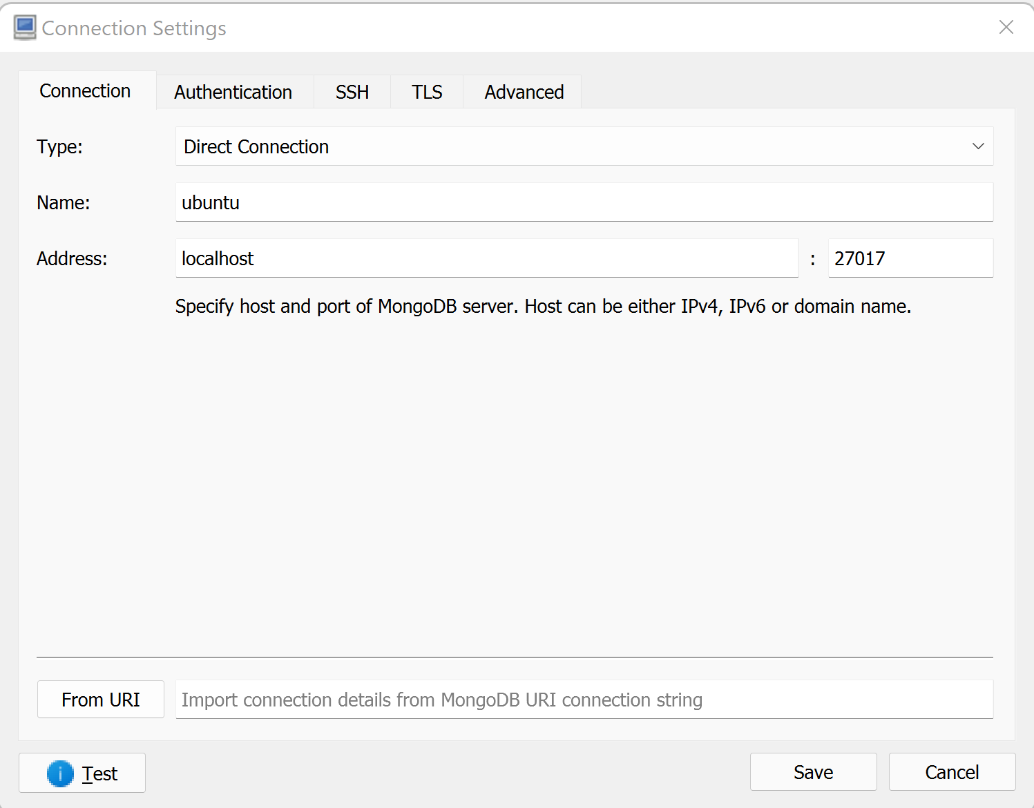

SSH tab:

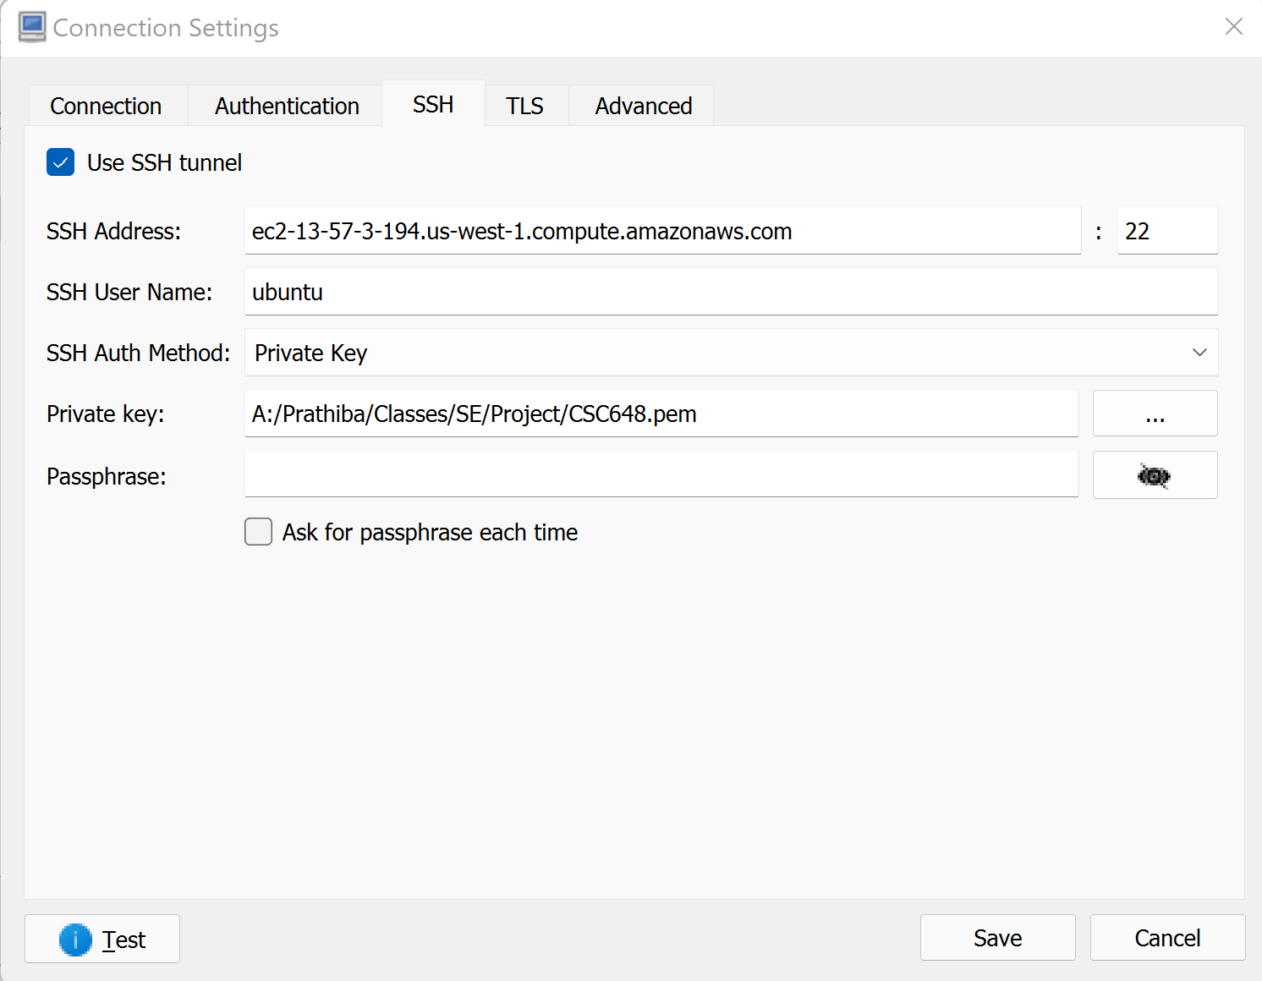

DB connect test result:

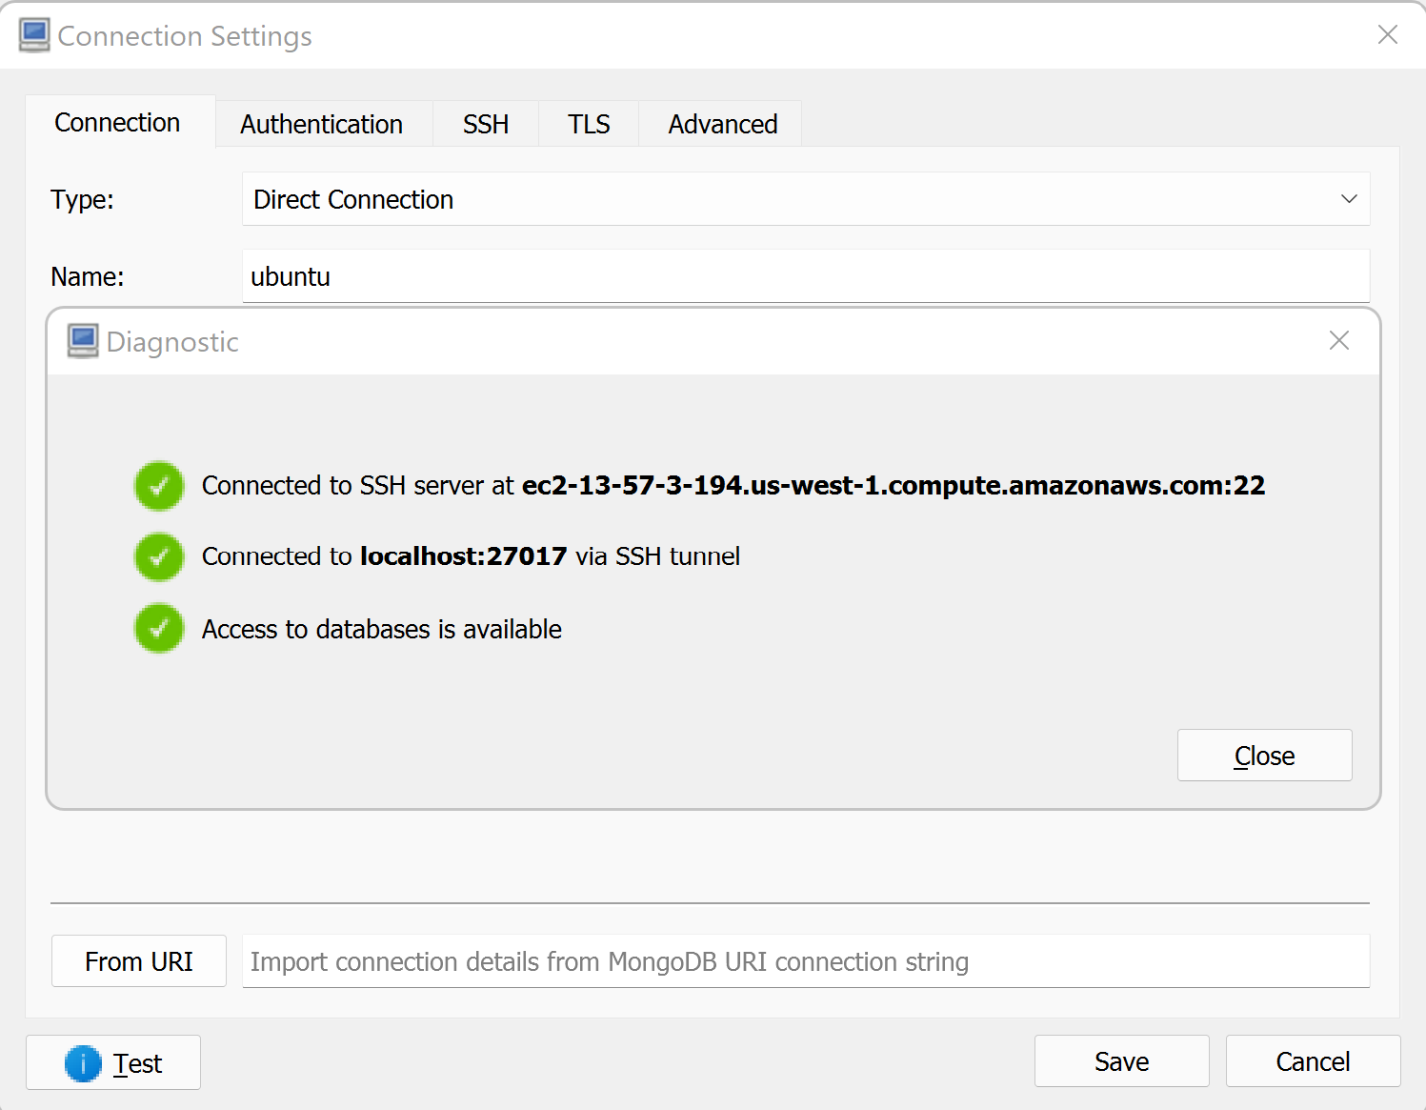

|  |
| --- |
| Addition information, anything to help with executing or grading of the current milestone |
| * In order to connect to our server, use the following command in terminal (Modify the key path in the below command),   ssh -i ~/Desktop/CSC648.pem -N -f -L 8000:localhost:27017 ubuntu@ec2-13-57-3-194.us-west-1.compute.amazonaws.com   * Below is the GitHub repository of our Team,   https://github.com/CSC-648-SFSU/csc648-spring22-01-Team02.git |